02.02
AIRCRAFT PHASE-IN
Process Design & AMOS Configuration Document
Purpose
This Process Design document is provided to Key-Users to record their key decisions regarding the AMOS Process design and the required AMOS configuration.
It is updated throughout the Project Definition Phase and used as the baseline for the Final Acceptance prior to Go-Live
Revision
Author, Name | Date | Notes
Jakub Sadowski | 01.06.2024 | First Version
Dimitri Dupont | 20.11.2024 | Rev 0

Table of Contents
1. Process Overview & Objectives 3
2. Regulatory References 3
3. Definitions & Glossary 3
4. Process Tasks 3
5. Process Dependencies 5
6. Process Flow 6
7. Process Design Questions 7
8. Data Source Mapping 8
9. Other Software Used 8
10. AMOS Configuration 9
a. Process specific configuration programmes 9
b. Basic Data 9
c. Parameters 10
d. Workflows 10
e. Scheduled Tasks 10
f. API’s & Interfaces 10
11. UAT Guidance 10
12. Annex – Additional Info 11

Process Overview & Objectives
Process General Description:
This process describes the various steps, either using Xfiles or manual entries to integrate an aircraft in the fleet.
When an aircraft (new or used) is first delivered to an operator, the airline must record all details like Registration, Part Number, Serial Number, owner, operator, the applicable Maintenance Program for all components within its maintenance planning and control system. This will also include details of the Flight Hours (H), Flight Cycles (C) undertaken to date by each component, plus the times already consumed on all installed life limited parts (LLP’s). An Aircraft Phase-In is a particularly extensive task, specially in the case of a used aircraft requiring a large amount of time and resources. Usually, the overall overview is performed by a Project Management experienced person who serves as a Phase-In Coordinator and checks that timelines and mile stones are kept.
Note that the process is similar if an aircraft that was archived/deactivated previously and is coming back into the fleet under the same registration, apart for the creation of the aircraft in AMOS.
The Phase-In process is a collection of multiple other processes that enables the adequate introduction of the aircraft in AMOS.
Main Process Objective (Outputs & Outcomes):
The main objective of this business process is to import all relevant aircraft data to the system.

Regulatory References
- EASA M.A.201 Responsibilities
- EASA M.A.307 Transfer of Aircraft Continuing Airworthiness Records.
- EASA M.A.305 Aircraft Continuing Airworthiness Record System
- EASA CAMO.A.220 Record-keeping
- EASA 145.A.55 Record-keeping

Definitions & Glossary
Key-Words | Explanation
XFile | An X-file is a data file used in AMOS for transferring data. It contains specific information about a particular object, such as a document, order, or check. Note that it is to be used with caution as it bypasses all safety embedded in the front end (manual entries restrictions).

Process Tasks
Mandatory prerequisite:
- The aircraft shall be already created in the system, refer to the Process 01.01 for aircraft creation.
Business Process Task / Actions / Activities:
  - Assign a Maintenance Program to the aircraft.
Each managed aircraft in AMOS shall have an assigned Maintenance Program (MP). Either this MP already exists and is applicable to the concerned Aircraft S/N, or it has to be created in AMOS.
The creation is possible either via Data Transfer (APN 261) or via manual entry in APN 249.

  - Import or create installed components & Assemblies, including subcomponents as required.
In order to have a complete configuration, the installed rotables must be created in the system. This can be done either via Data Transfer (APN: 261), via Airbus Aircraft Setup (APN: 635) or via manual entries in Rotable Administration (APN: 147).
In case this is a completely new operated aircraft type, the unknown part numbers must be created upfront in accordance with Process 01.02.
This task is for components and assemblies, meaning engines APU and their respective subcomponents, hence it can be divided in two tasks.

  - Import or create softwares
Same as for the components and assemblies, the installed softwares need to be created in the system. The Data Transfert (APN 261) is a possibility or it can be done manually via APN 1828.
All unknown software number have to be create upfront in accordance with Process 01.02. using APN 2618.
  - Import or create component requirements.
Component requirements can be implemented via Transfer-Data APN in AMOS. Information is provided by either manufacturer or OEM of parts.

  - Import or create the aircraft modification status.
In order to show an airworthiness status of the aircraft, the setup of modification (recommended and/or mandatory) is essential. Modifications can be setup manually (APN: 63) or via the Data Transfer (APN: 261).
Note that each new modification should be assessed adequately prior releasing.

  - Create Deferred defects and any other relevant open unscheduled maintenance.
The creation of these events is a manual entry to be performed in APN 1418.

  - Initialize MP tasks and checks.
Initialization of the tasks and checks can be done either via Data Transfer (APN 261) or manually in APN 1895. Check the tabsheets "Initialization"; "Sync. MP Revision" and "Sync. Time Requirement".
It is recommended to use the last performed date to allow AMOS to calculate the next due based on the assigned Maintenance Program and specific parts requirements. “Next due” shall be used when no “last performed” date is existing, for new requirements for example.

  - Assign an Aircraft Configuration to the Aircraft.
    - 4.5.1 New aircraft type (never flown in the company)
Create a new allowed aircraft configuration for this aircraft type in Configuration Definition (APN 2818). Thereafter compare the installed components with the allowed configuration which has been generated previously.
    - 4.5.2 Existing Aircraft type (allowed configuration already available for given aircraft type)
Check if new aircraft can be fit into allowed configuration. In this case, add aircraft serial number into allowed configuration effectivity and amend the allowed configuration if required (e.g. if different components installed, etc.). Otherwise, a new configuration shall be created.
  - Record aircraft Weight & Balance
it is recommended to enter the weight & balance of the aircraft during the Phase In process using APN 292.
For a new aircraft type, please refer to the process 01.08 for the setup.
  - Record Dent & buckle chart
The historical entries of the can be entered and positioned in the charts directly using APN 786.
It is possible to use Xfile to upload the damages in the dent & buckle chart, but a prerequisite is to have the chart already adequately named and uploaded.
  - Create a bridging check.
If needed and pending on activities, it is possible to create a bridging check to align requirements due dates. Please refer to Process 03.02 for the workpackage generation.

Process Dependencies
INPUT | CONCURRENT | OUTPUT
- 01.01 – Aircraft definition  - 01.03 – Aircraft Maintenance program  - 01.04 – SB & AD assessment  - 01.05 – Configuration Management  - 01.06 – MEL administration  - 01.08 – Weight & Balance  - 02.04 Aircraft & Comp. Counters  - 02.07 – Structural Damages  - 02.09 – Airworthiness Certificate |  | - 01.07 – Reliability  - 03.01 – Planning  - 03.02 - Work Package Generation  - 03.03 – Reporting Back  - 03.04 – Modification Campaign  - 03.05 – Long Term Planning  - 05.01 Aircraft Acceptance  - 05.02 Pilot Reports (PIREPS)  - 05.03 Cabin Defects  - 05.04 Flight Closing  - 08.01 Maintenance Check Control  - 08.02 Performing Maintenance  - 08.03 Deferral Handling  - 08.04 Parts Removal & Installation  - 08.05 Maintenance Release to Service

Process Flow

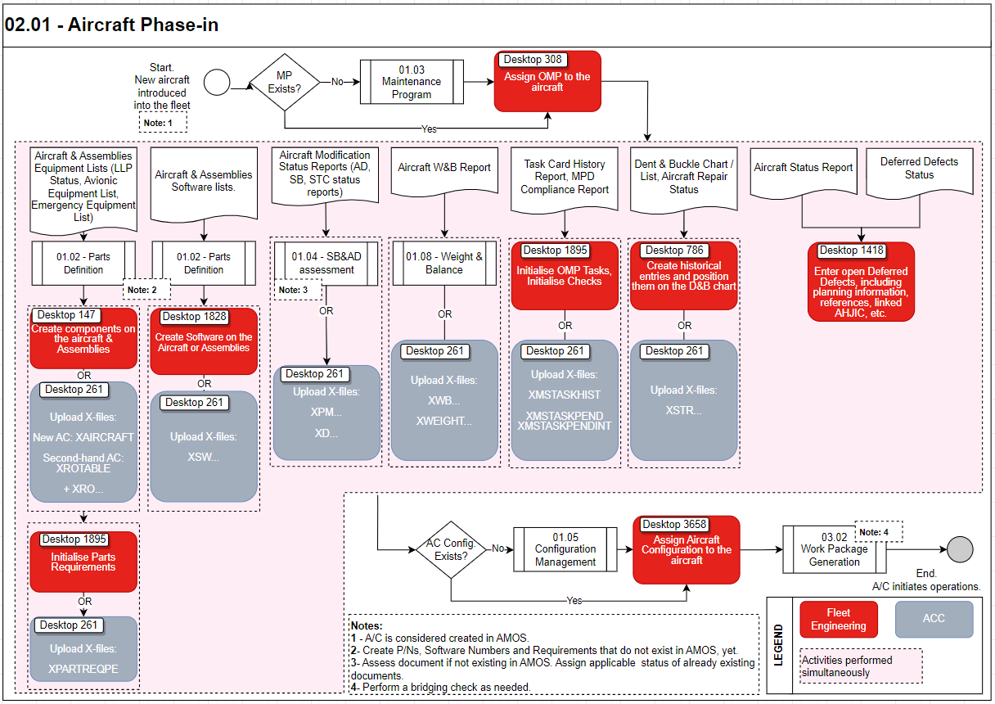

Process Design Questions
# | Question | Answer
How is a phase-in process handled in your company?
Is the phase-in/out process driven by Technical Department or do you have a special Project Department?
 | Are there internal capabilities (e.g. in IT department) if any advanced data transformation was required to streamline / correct batch imported data?
 | Are the tasks centralized to a focal point that handles all the documentation or is this task split among different departments?
 | Do you create any reports after phase-in?
Is the Aircraft new or pre-owned?
Do you import the complete maintenance history, limited historical data, or only current snapshot / status of the AC?
 | What type of fleet / AC is going to be phased in? Is the AC e-enabled?
 | What is your policy / requirement regarding Configuration Management?

Data Source Mapping
Data Sources | Description | Volume / Manual / Automatic / Static / Dynamic
XFILES | Standard method of uploading bulk data into AMOS – use APN 261 | Depending on file
XML imports | Boeing SGML  Boeing Toolbox  Airbus TSDF | Uploading MP / MP revision from XML files
 | S1000D format | OEM Documents import
Netline | Netline data import in APN 10 | Integration / bulk import, after initial sync - dynamic
Boeing 787 Authorized  Configuration Parser  (APN 2333) | The purpose of the Boeing 787 Authorized Configuration Parser is to parse the As Delivered Authorized  Configuration XML and create AMOS import files
Airbus MMEL Import  (APN 1070) | This Airbus MMEL Import
APN 2818 / Allowed
Configurations Import.
ATA SPEC 2300 XML
import function.

Other Software Used
Other Software | Used by: | Description
-/- | -/- | -/-

AMOS Configuration

Process specific configuration programmes
AMOS APN | Notes
APN18 - Basic Data Administration | Update necessary Basic Data Tables if required
APN 308 - Aircraft Admistration | Assign the MP to the aircraft
APN 261 – Data Transfer | Define and prepare the relevant Xfiles needed for the Phase In. Check the consistency and upload them in AMOS.
APN147 – Rotables Administration | Create the rotables on the aircrafts, including major components and their subcomponents as required.
APN 786 – Structural Damage | Create the historical structural damages entries and positions
APN 1895 – Maintenance Event Initialiser | Initialize the parts requirements, the tasks and the checks
APN 1418 – Workorder | Enter unscheduled maintenance events
APN 3658 – Configuration Assignment | Assign a configuration to the aircraft
APN 1828 – Software Booking | Create the software on the aircraft and assemblies.

Basic Data
Basic Data Table | Notes
Ref. to Basic Data Tables of each sub-process | -/-

Parameters
Parameter Code | Parameter Name | Notes
1609 | Data Transfer Statistics Update | Enable or disable the automatic statistic updates triggered by data transfer on the server:  String value = "Y" -> Statistics updates are enabled  String value = "N" -> Statistics updates are disabled
1718 | Enable multiple workers for selected data transfer files | This parameter enables the data transfer module to run specific transfer files on multiple workers. This reduces the import duration.
1270 | CALC. TOGO/EXP-DATE DIRECTLY | With this parameter you can define when the calculation of Togo/Expected-Date shall take place in Rotable Admin / Load-Tree.
1362 | NORMALIZE SERIALNUMBERS | Normalize serialnumbers (remove spaces) by entering new rotables in the system.
1430 | BASIC DATA FOR ROTABLE MOD. STATUS | Allows the Mod. Info fields available in Rotable Administration should be controlled via Plate Mod. Status data.

Workflows
Workflow Number | Workflow Name | Workflow Setup Notes
398 | Data Transfer Finished | To be used if customer wants to trigger actions once a data transfer is finished.
337 | Rotable | This workflow is triggered when a rotable is created, modified or deleted in Rotables Administration.
Refer to WF list of each related sub-process

Scheduled Tasks
Scheduled Task Reference | Frequency | Notes
-/-

API’s & Interfaces
Reference | Direction | Trigger | Frequency
-/-

UAT Guidance
Test case number | Test case description | Required data | Required resources
1 | Check actual A/C configuration status | Parts lists. LLP list, Engine and APU with subcomponent list. Software list. | Engineering
2 | Check next due date consistency | Last performed date of tasks and Checks. | Engineering
3 | Check modification status report | SB/AD & modification list | Engineering
4 | Check the Structural Damages records | Previous Dent & Buckle chart | Engineering
5 | Check Weight and Balance data | Previous Weight & Balance | Engineering
6 | Check open items/deferred defects/Open Unscheduled maintenance events | A/Status report and Deferred Defect Status | Engineering

Annex – Additional Info
-/-

